
St. James’ Primary Academy

St. James’ Primary Academy Calculation Policy for Lower Key Stage Two
The following pages show the progression in calculation (addition, subtraction, multiplication and division) and how this works in line with the National Curriculum. The consistent use of the CPA (concrete, pictorial, abstract) approach across the curriculum helps children develop mastery across all the operations in an efficient and reliable way. This policy shows how these methods develop children’s confidence in their understanding of both written and mental methods.

St. James’ Primary Academy Progression of Mathematical Calculation Methods
 | EYFS/Year 1 | Year 2 | Year 3 | Year 4 | Year 5 | Year 6
Addition | Combining two parts to make a whole: part whole model  Starting at the bigger number and counting on- using cubes  Regrouping to make 10 using ten frame | Adding three single digits  Use of dienes to combine two numbers | Column method- regrouping  Using place value counters/dienes  (up to 3 digits)  Pictorial representations of dienes | Column method- regrouping  (up to 4 digits)  Pictorial representations of dienes | Column method- regrouping  Use of place value counters for adding decimals | Column method- regrouping  Abstract methods  Place value counters to be used for adding decimal numbers
Subtraction | Taking away ones  Counting back  Find the difference  Part whole model  Make 10 using the ten frame | Counting back  Find the difference  Part whole model  Make 10  Use of dienes | Column method with regrouping  (up to 3 digits using place value counters)  Pictorial representations of dienes | Column method with regrouping  (up to 4 digits)  Pictorial representations of dienes | Column method with regrouping  Abstract for whole numbers  Start with place value counters for decimals- with the same amount of decimal places | Column method with regrouping  Abstract methods  Place value counters for decimals- with different amounts of decimal places
Multiplication | Recognising and making equal groups]  Doubling  Counting in multiples  Use of cubes, numicon and other objects in the classroom | Arrays- showing commutative multiplication | Arrays  2d × 1d using dienes and, when appropriate, column method alongside  Pictorial representations of dienes | Column multiplication- introduced with place value counters and dienes  (2 and 3 digit multiplied by 1 digit)  Pictorial representations of dienes | Column multiplication  Abstract only but might need a repeat of year 4 first (up to 4 digit numbers multiplied by 1 or 2 digits) | Column multiplication  Abstract methods  (multi-digit up to 4 digits by a 2 digit number)
Division | Sharing objects into groups  Division as grouping e.g. I have 12 sweets and put them in groups of 3, how many groups?  Use cubes and draw round 3 cubes at a time. | Division as grouping  Division within arrays- linking to multiplication  Repeated subtraction | Division with a remainder-using lollipop sticks, times tables facts and repeated subtraction  2d divided by 1d using dienes or place value counters  Short division when appropriate alongside concrete and pictorial representations | Division with a remainder  Short division (up to 3 digits by 1 digit- concrete and pictorial) | Short division  (up to 4 digits by a 1 digit number including remainders) | Short division  Long division with place value counters  (up to 4 digits by a 2 digit number)  Children should exchange into the tenths and hundredths column too

LOWER KEY STAGE TWO
In Years 3 and 4, children develop the basis of written methods by building their skills alongside a deep understanding of place value. They should use known addition/subtraction and multiplication/division facts to calculate efficiently and accurately, rather than relying on counting. Children use place value equipment to support their understanding, but not as a substitute for thinking.
Key language: partition, place value, tens, hundreds, thousands, column method, whole, part, equal groups, sharing, grouping, bar model
Addition and subtraction: In Year 3 especially, the column methods are built up gradually. Children will develop their understanding of how each stage of the calculation, including any exchanges, relates to place value. The example calculations chosen to introduce the stages of each method may often be more suited to a mental method. However, the examples and the progression of the steps have been chosen to help children develop their fluency in the process, alongside a deep understanding of the concepts and the numbers involved, so that they can apply these skills accurately and efficiently to later calculations. The class should be encouraged to compare mental and written methods for specific calculations, and children should be encouraged at every stage to make choices about which methods to apply.  In Year 4, the steps are shown without such fine detail, although children should continue to build their understanding with a secure basis in place value. In subtraction, children will need to develop their understanding of exchange as they may need to exchange across one or two columns.  By the end of Year 4, children should have developed fluency in column methods alongside a deep understanding, which will allow them to progress confidently in upper Key Stage 2. | Multiplication and division: Children build a solid grounding in times-tables, understanding the multiplication and division facts in tandem. As such, they should be as confident knowing that 35 divided by 7 is 5 as knowing that 5 times 7 is 35.  Children develop key skills to support multiplication methods: unitising, commutativity, and how to use partitioning effectively.  Unitising allows children to use known facts to multiply and divide multiples of 10 and 100 efficiently. Commutativity gives children flexibility in applying known facts to calculations and problem solving. An understanding of partitioning allows children to extend their skills to multiplying and dividing 2- and 3-digit numbers by a single digit.  Children develop column methods to support multiplications in these cases.  For successful division, children will need to make choices about how to partition. For example, to divide 423 by 3, it is effective to partition 423 into 300, 120 and 3, as these can be divided by 3 using known facts.  Children will also need to understand the concept of remainder, in terms of a given calculation and in terms of the context of the problem. | Fractions: Children develop the key concept of equivalent fractions, and link this with multiplying and dividing the numerators and denominators, as well as exploring the visual concept through fractions of shapes. Children learn how to find a fraction of an amount, and develop this with the aid of a bar model and other representations alongside.  in Year 3, children develop an understanding of how to add and subtract fractions with the same denominator and find complements to the whole. This is developed alongside an understanding of fractions as numbers, including fractions greater than 1. In Year 4, children begin to work with fractions greater than 1.  Decimals are introduced, as tenths in Year 3 and then as hundredths in Year 4. Children develop an understanding of decimals in terms of the relationship with fractions, with dividing by 10 and 100, and also with place value.

Year 3
 | Concrete | Pictorial | Abstract
Year 3
Addition
Understanding 100s | Understand the cardinality of 100, and the link with 10 tens.  Use cubes to place into groups of 10 tens.  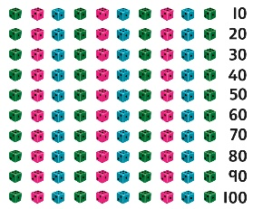  Unitise 100 and count in steps of 100.  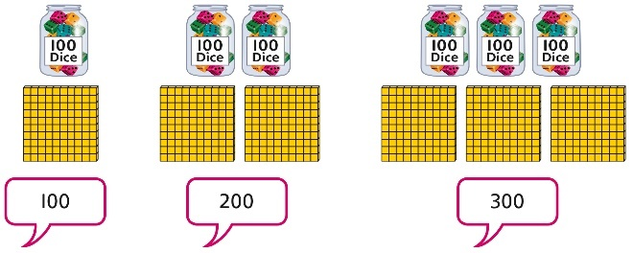 | Draw numbers to represent counts of 100.  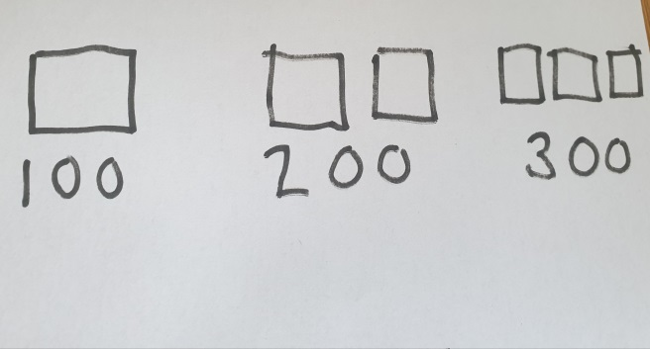 | Represent steps of 100 on a number line and a number track and count up to 1,000 and back to 0.  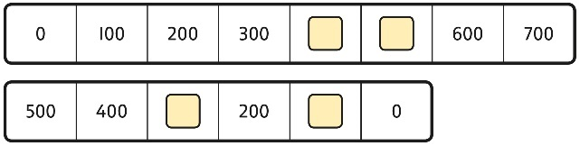
Understanding place value to 1,000 | Unitise 100s, 10s and 1s to build 3-digit numbers.  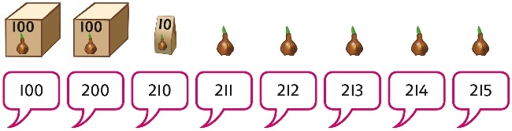  Use equipment to represent numbers to 1,000.  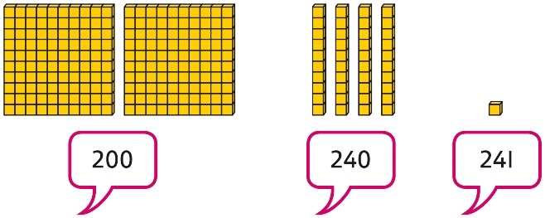  Use a place value grid to support the structure of numbers to 1,000.  Place value counters are used alongside other equipment. Children should understand how each counter represents a different unitised amount. | Use pictorial representations to show numbers up to 1,000.  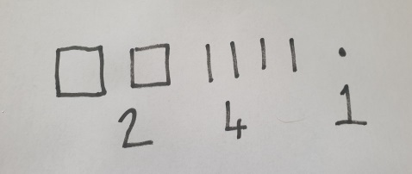 | Represent the parts of numbers to 1,000 using a part-whole model.  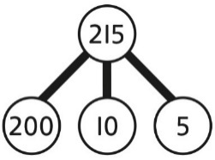  215 = 200 + 10 + 5  Recognise numbers to 1,000 represented on a number line, including those between intervals.
Adding 100s | Use known facts and unitising to add multiples of 100.  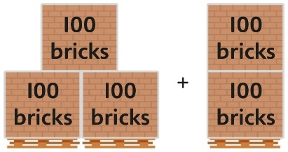  3 + 2 = 5  3 hundreds + 2 hundreds = 5 hundreds  300 + 200 = 500 | Use known facts and unitising to add multiples of 100.  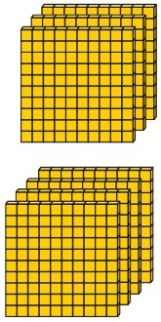  3 + 4 = 7  3 hundreds + 4 hundreds = 7 hundreds  300 + 400 = 700  You can also represent this pictorally | Use known facts and unitising to add multiples of 100.  Represent the addition on a number line.  Use a part-whole model to support unitising.  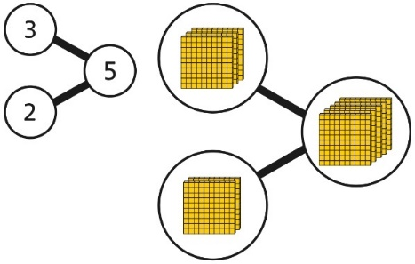  3 + 2 = 5  300 + 200 = 500
3-digit number + 1s, no exchange or bridging | Use number bonds to add the 1s.  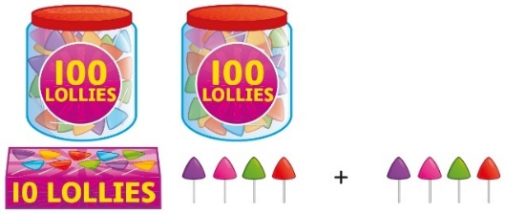  214 + 4 = ?  Now there are 4 + 4 ones in total.  4 + 4 = 8  214 + 4 = 218 | Use number bonds to add the 1s.  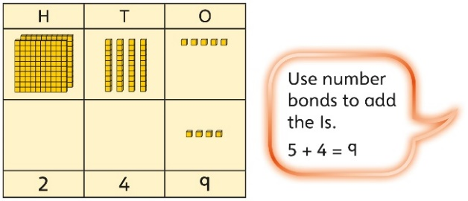  245 + 4  5 + 4 = 9  245 + 4 = 249 | Understand the link with counting on.  245 + 4  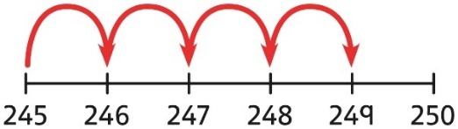  Use number bonds to add the 1s and understand that this is more efficient and less prone to error.  245 + 4 = ?  I will add the 1s.  5 + 4 = 9  So, 245 + 4 = 249
3-digit number + 1s with regroup | Understand that when the 1s sum to 10 or more, this requires an exchange of 10 ones for 1 ten.  Children should explore this using unitised objects or physical apparatus.  Exchange 10 ones for 1 ten where needed. Use a place value grid to support the understanding.  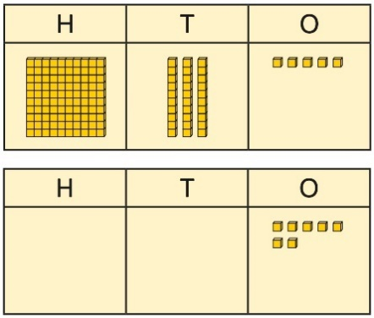  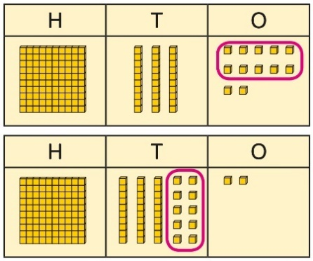  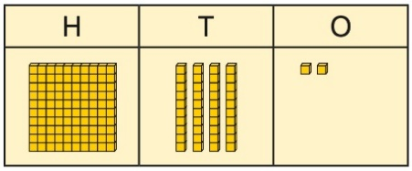  135 + 7 = 142 | Model this process using pictorial representations, exchanging ten ones for one ten.  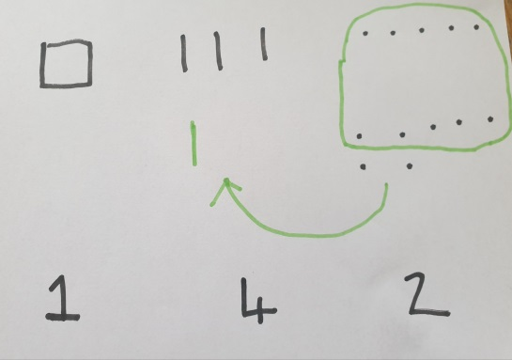 | Understand how to bridge by partitioning to the 1s to make the next 10.  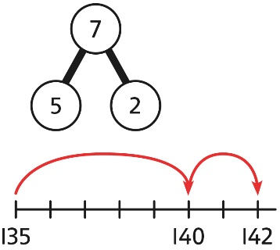  135 + 7 = ?  135 + 5 + 2 = 142  Ensure that children understand how to add 1s bridging a 100.  198 + 5 = ?  198 + 2 + 3 = 203
3-digit number + 10s, no exchange | Calculate mentally by forming the number bond for the 10s.  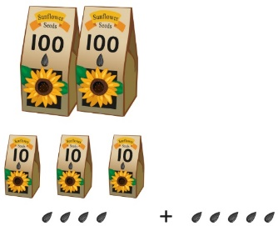  234 + 50  There are 3 tens and 5 tens altogether.  3 + 5 = 8  In total there are 8 tens.  234 + 50 = 284 | Calculate mentally by forming the number bond for the 10s.  351 + 30 = ?  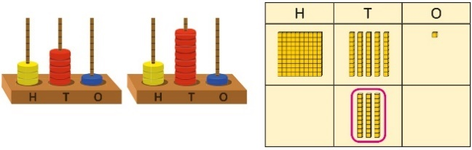  5 tens + 3 tens = 8 tens  351 + 30 = 381 | Calculate mentally by forming the number bond for the 10s.  753 + 40  I know that 5 + 4 = 9  So, 50 + 40 = 90  753 + 40 = 793
3-digit number + 10s, with exchange | Understand the exchange of 10 tens for 1 hundred.  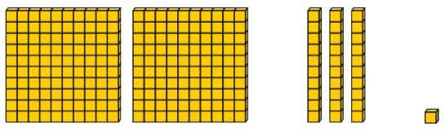  Add by exchanging 10 tens for 1 hundred.  184 + 20 = ?  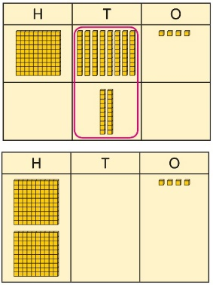  184 + 20 = 204 | Model exchanging ten tens for one one hundred pictorially.  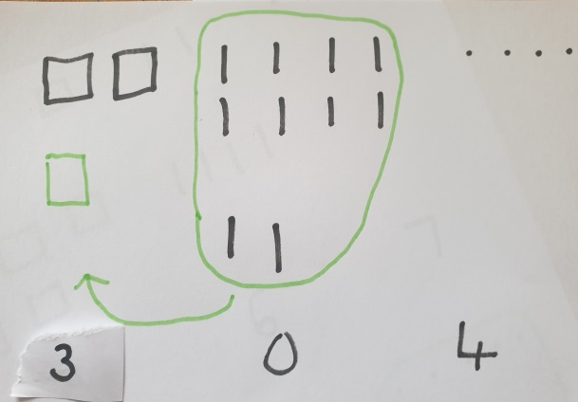 | Understand how the addition relates to counting on in 10s across 100.  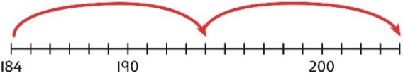  184 + 20 = ?  I can count in 10s … 194 … 204  184 + 20 = 204  Use number bonds within 20 to support efficient mental calculations.  385 + 50  There are 8 tens and 5 tens.  That is 13 tens.  385 + 50 = 300 + 130 + 5  385 + 50 = 435
3-digit number + 2-digit number | Use place value equipment to make and combine groups to model addition.  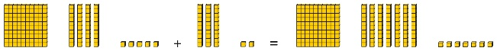 | Use a place value grid to organise thinking and adding of 1s, then 10s. | Use the vertical column method to represent the addition. Children must understand how this relates to place value at each stage of the calculation.
3-digit number + 2-digit number, exchange required | Use place value equipment to model addition and understand where exchange is required.  Represent the required exchange on a place value grid using equipment.  275 + 16 = ?  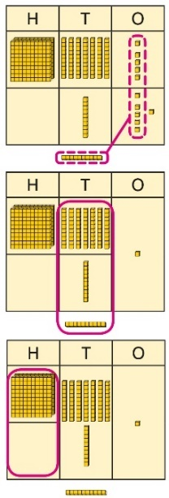  275 + 16 = 291  Note: In this example, a mental method may be more efficient. The numbers for the example calculation have been chosen to allow children to visualise the concept and see how the method relates to place value.  Children should be encouraged at every stage to select methods that are accurate and efficient. | 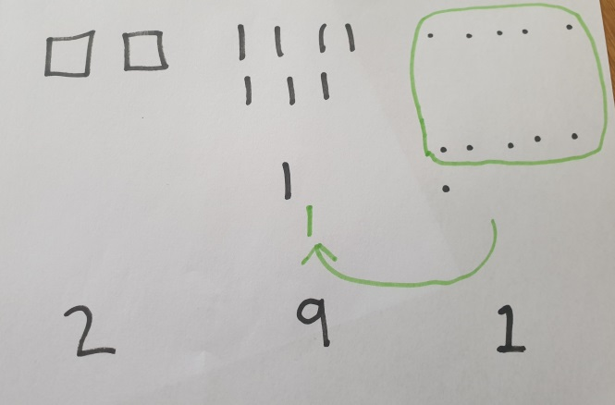  Use pictorial representations to demonstrate the exchanging of ten ones for one ten, emphasising that these are the same. | Use a column method with exchange. Children must understand how the method relates to place value at each stage of the calculation.  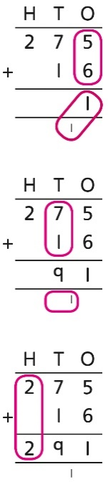  275 + 16 = 291
3-digit number + 3-digit number, no exchange | Use place value equipment to make a representation of a calculation. This may or may not be structured in a place value grid.  326 + 541 is represented as:  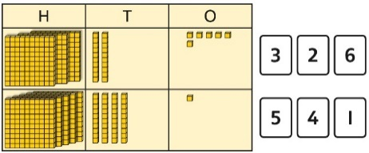 | 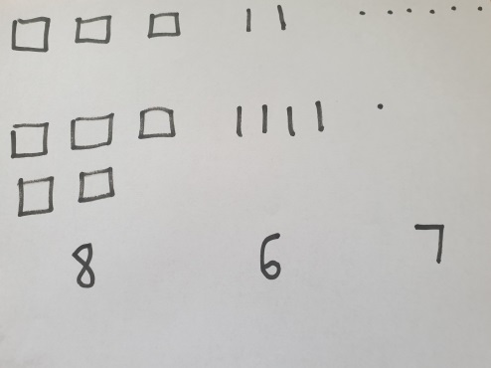  Represent the place value grid with pictorial representations to model the stages of column addition. | Use a column method to solve efficiently, using known bonds. Children must understand how this relates to place value at every stage of the calculation.
3-digit number + 3-digit number, exchange required | Use place value equipment to enact the exchange required.  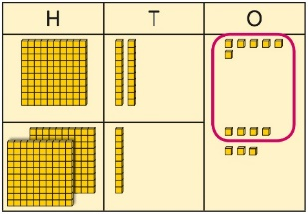  There are 13 ones.  I will exchange 10 ones for 1 ten.  Model the stages of column addition using place value equipment on a place value grid.  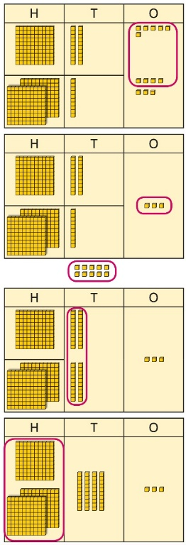 | 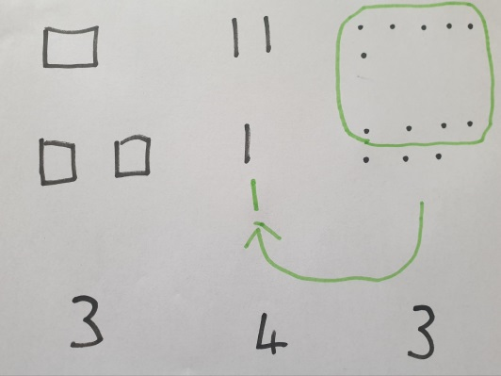  Model the exchange using pictorial | Use column addition, ensuring understanding of place value at every stage of the calculation.  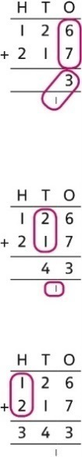  126 + 217 = 343  Note: Children should also study examples where exchange is required in more than one column, for example 185 + 318 = ?
Representing addition problems, and selecting appropriate methods | Encourage children to use their own drawings and choices of place value equipment to represent problems with one or more steps.  These representations will help them to select appropriate methods. | Children understand and create bar models to represent addition problems.  275 + 99 = ?  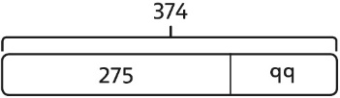  275 + 99 = 374 | Use representations to support choices of appropriate methods.  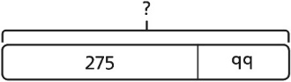  I will add 100, then subtract 1 to find the solution.  128 + 105 + 83 = ?  I need to add three numbers.  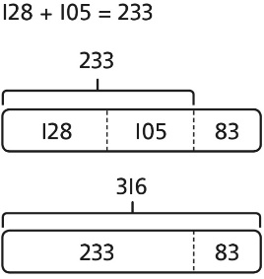
Year 3
Subtraction
Subtracting 100s | Use known facts and unitising to subtract multiples of 100.  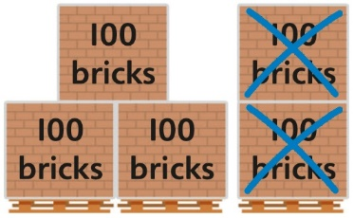  5 − 2 = 3  500 − 200 = 300  Use known facts and unitising to subtract multiples of 100.  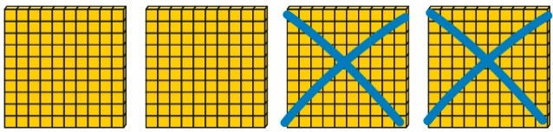  4 − 2 = 2  400 − 200 = 200 | Model drawing the 100s and then crossing out the required amount.  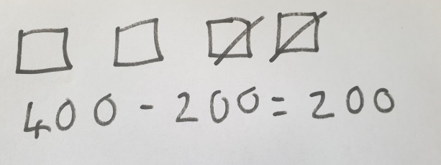 | Understand the link with counting back in 100s.  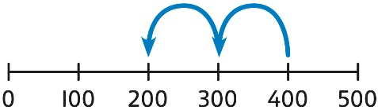  400 − 200 = 200  Use known facts and unitising as efficient and accurate methods.  I know that 7 − 4 = 3. Therefore, I know that 700 − 400 = 300.
3-digit number − 1s, no exchange | Use number bonds to subtract the 1s.  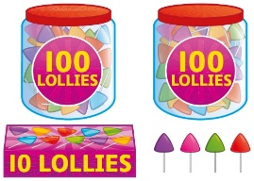  214 − 3 = ?  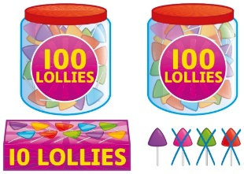  4 − 3 = 1  214 − 3 = 211 | Use number bonds to subtract the 1s (this can and should be done mentally).  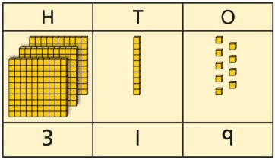  319 − 4 = ?  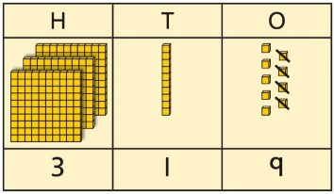  9 − 4 = 5  319 − 4 = 315 | Understand the link with counting back using a number line.  Use known number bonds to calculate mentally.  476 − 4 = ?  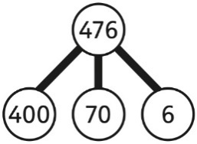  6 − 4 = 2  476 − 4 = 472
3-digit number − 1s, exchange or bridging required | Understand why an exchange is necessary by exploring why 1 ten must be exchanged.  Represent the required exchange on a place value grid.  151 − 6 = ?  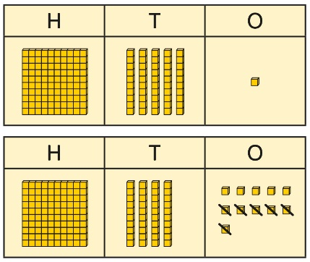 | 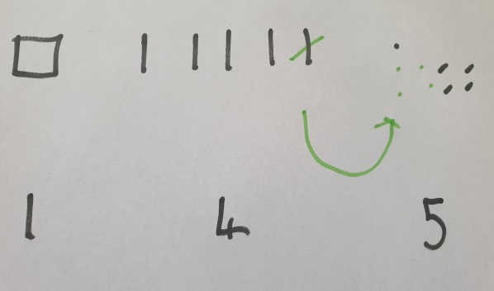  If needed, represent the exchange pictorially, although this should be done mentally. | Calculate mentally by using known bonds.  151 − 6 = ?  151 − 1 − 5 = 145
3-digit number − 10s, no exchange | Subtract the 10s using known bonds.  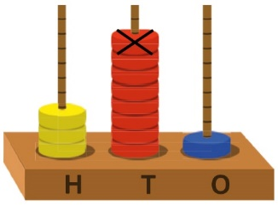  381 − 10 = ?  8 tens with 1 removed is 7 tens.  381 − 10 = 371 | Subtract the 10s using known bonds.  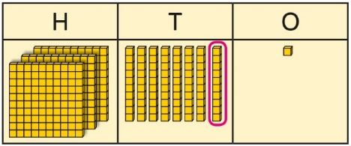  8 tens − 1 ten = 7 tens  381 − 10 = 371 | Use known bonds to subtract the 10s mentally.  372 − 50 = ?  70 − 50 = 20  So, 372 − 50 = 322
3-digit number − 10s, exchange or bridging required | Use equipment to understand the exchange of 1 hundred for 10 tens.  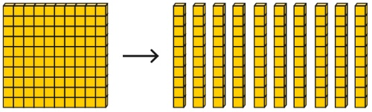 | Represent the exchange on a place value grid using equipment.  210 − 20 = ?  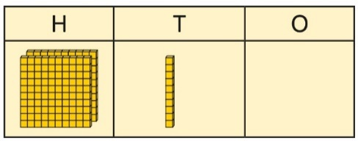  I need to exchange 1 hundred for 10 tens, to help subtract 2 tens.  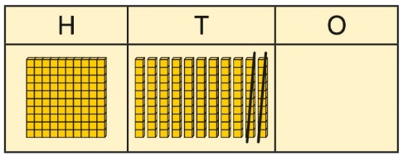  210 − 20 = 190 | Understand the link with counting back on a number line.  Use flexible partitioning to support the calculation.  235 − 60 = ?  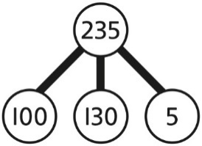  235 = 100 + 130 + 5  235 − 60 = 100 + 70 + 5  = 175
3-digit number − up to 3-digit number | Represent the calculation on a place value grid.  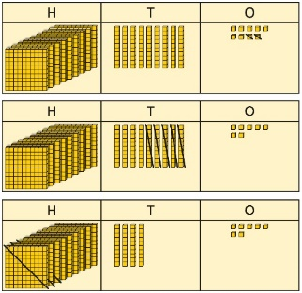 | Represent the calculation pictorially, crossing off the numbers that are to be subtracted.  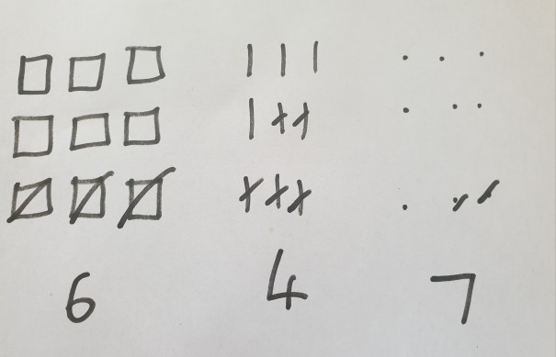 | Use column subtraction to calculate accurately and efficiently.  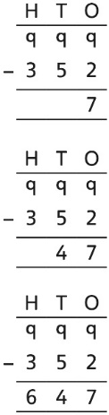
3-digit number − up to 3-digit number, exchange required | Use equipment to enact the exchange of 1 hundred for 10 tens, and 1 ten for 10 ones.  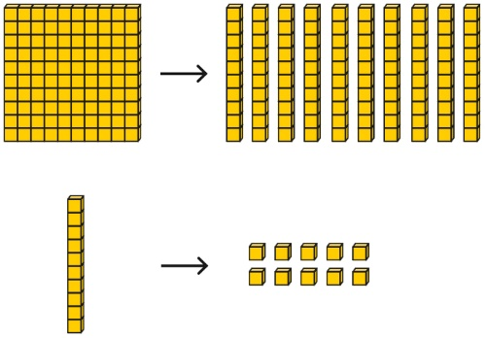  Model the required exchange on a place value grid.  175 − 38 = ?  I need to subtract 8 ones, so I will exchange a ten for 10 ones.  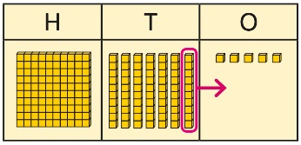  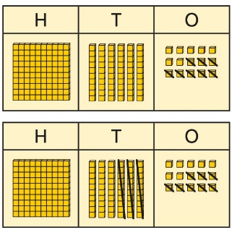 | 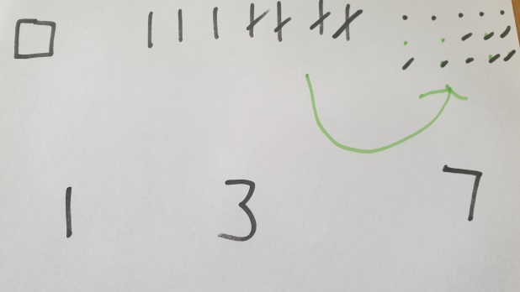  Model the exchange of one ten for ten ones within the calculation pictorially. | Use column subtraction to work accurately and efficiently.  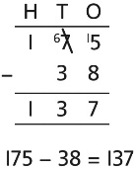  If the subtraction is a 3-digit number subtract a 2-digit number, children should understand how the recording relates to the place value, and so how to line up the digits correctly.  Children should also understand how to exchange in calculations where there is a zero in the 10s column.  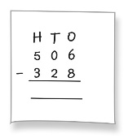
3-digit number − up to 3-digit number, exchange required | Column method using place value counters.  234 – 88 | Represent the place value counters pictorially; remembering to show what has been exchanged. | Formal column method. Children must understand what has happened when they have crossed out digits.
Representing subtraction problems |  | Use bar models to represent subtractions.  ‘Find the difference’ is represented as two bars for comparison.  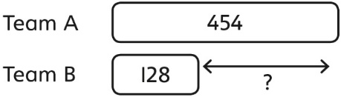  Bar models can also be used to show that a part must be taken away from the whole. | Children use alternative representations to check calculations and choose efficient methods.  Children use inverse operations to check additions and subtractions.  The part-whole model supports understanding.  I have completed this subtraction.  525 − 270 = 255  I will check using addition.  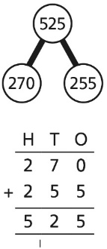
Year 3
Multiplication
Understanding equal grouping and repeated addition | Children continue to build understanding of equal groups and the relationship with repeated addition.  They recognise both examples and non-examples using objects.  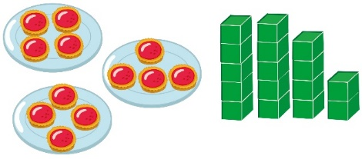  Children recognise that arrays can be used to model commutative multiplications.  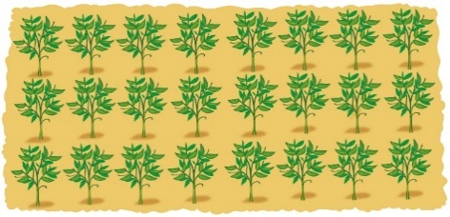  I can see 3 groups of 8.  I can see 8 groups of 3. | Children recognise that arrays demonstrate commutativity.  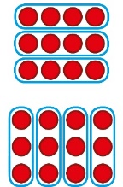  This is 3 groups of 4.  This is 4 groups of 3. | Children understand the link between repeated addition and multiplication.  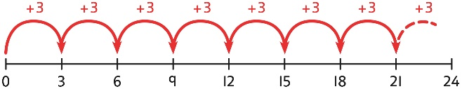  8 groups of 3 is 24.  3 + 3 + 3 + 3 + 3 + 3 + 3 + 3 = 24  8 × 3 = 24  A bar model may represent multiplications as equal groups.  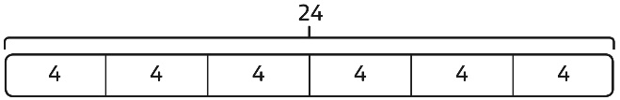  6 × 4 = 24
Using commutativity to support understanding of the times-tables | Understand how to use times-tables facts flexibly.  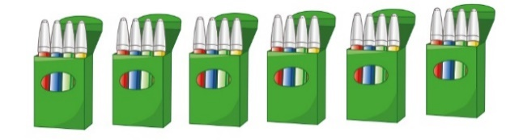  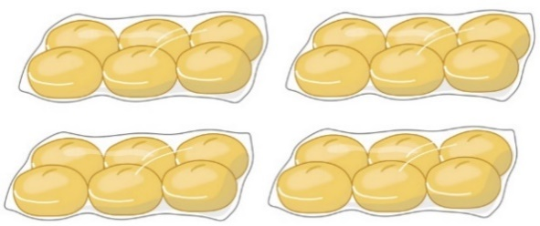  There are 6 groups of 4 pens.  There are 4 groups of 6 bread rolls.  I can use 6 × 4 = 24 to work out both totals. | Understand how times-table facts relate to commutativity.  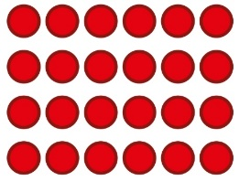  6 × 4 = 24  4 × 6 = 24 | Understand how times-table facts relate to commutativity.  I need to work out 4 groups of 7.  I know that 7 × 4 = 28  so, I know that  4 groups of 7 = 28  and  7 groups of 4 = 28.
Number lines to show repeated groups | 3 × 4  Cuisenaire rods can be used too. | Represent this pictorially alongside a number line e.g.: | 3 × 4 = 12  4 + 4 + 4 = 12
Understanding and using ×3, ×2, ×4 and ×8 tables. | Children learn the times-tables as ‘groups of’, but apply their knowledge of commutativity.  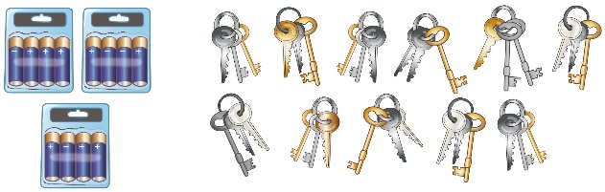  I can use the ×3 table to work out how many keys.  I can also use the ×3 table to work out how many batteries. | Children understand how the ×2, ×4 and ×8 tables are related through repeated doubling.  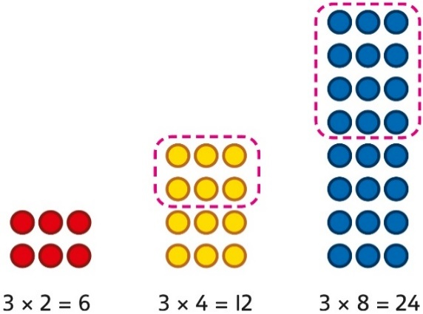 | Children understand the relationship between related multiplication and division facts in known times-tables.  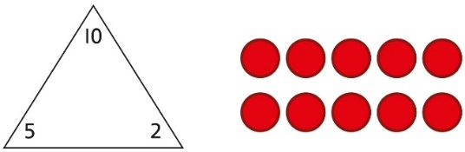  2 × 5 = 10  5 × 2 = 10  10 ÷ 5 = 2  10 ÷ 2 = 5
Understanding and using ×3, ×2, ×4 and ×8 tables. | Repeated grouping/repeated addition  3 × 4  4 + 4 + 4  There are 3 equal groups, with 4 in each group. | Children to represent the practical resources in a picture and use a bar model. | 3 × 4 = 12  4 + 4 + 4 = 12
Using known facts to multiply 10s, for example  3 × 40 | Explore the relationship between known times-tables and multiples of 10 using place value equipment.  Make 4 groups of 3 ones.  Make 4 groups of 3 tens.  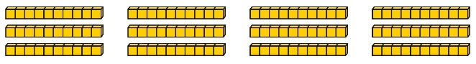  What is the same?  What is different? | Understand how unitising 10s supports multiplying by multiples of 10.  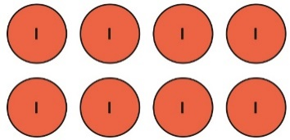  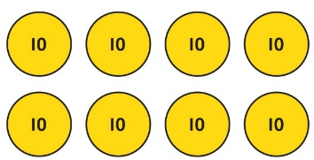  4 groups of 2 ones is 8 ones.  4 groups of 2 tens is 8 tens.  4 × 2 = 8  4 × 20 = 80 | Understand how to use known times-tables to multiply multiples of 10.  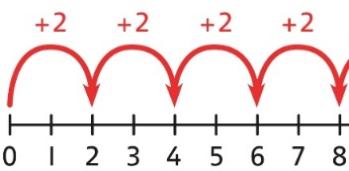  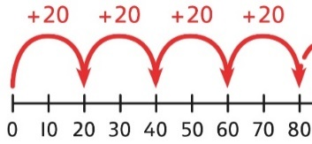  4 × 2 = 8  4 × 20 = 80
Multiplying a  2-digit number by a 1-digit number | Understand how to link partitioning a 2-digit number with multiplying.  Each person has 23 flowers.  Each person has 2 tens and 3 ones.  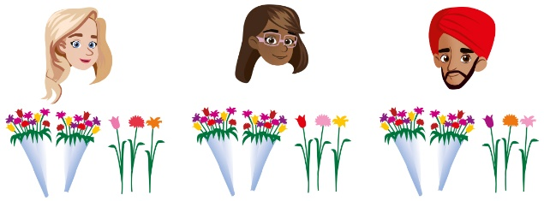  There are 3 groups of 2 tens.  There are 3 groups of 3 ones.  Use place value equipment to model the multiplication context.  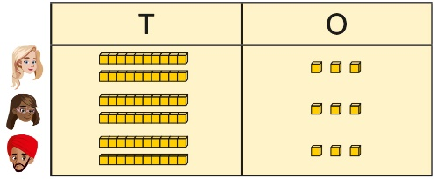  There are 3 groups of 3 ones.  There are 3 groups of 2 tens. | Use place value to support how partitioning is linked with multiplying by a 2-digit number.  3 × 24 = ?  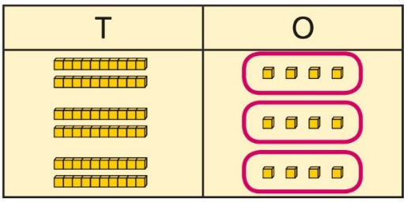  3 × 4 = 12  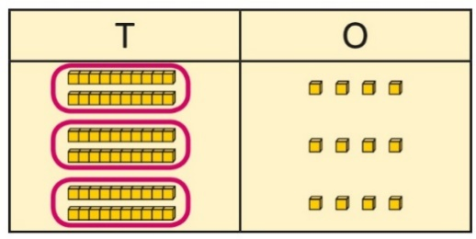  3 × 20 = 60  60 + 12 = 72  3 × 24 = 72 | Use partitioning to multiply numbers.  2 x 3 = 6  20 x 3 = 60  3 x 4 = 12  60 + 12 = 72  If needed, you can use pictorial representations to support this:  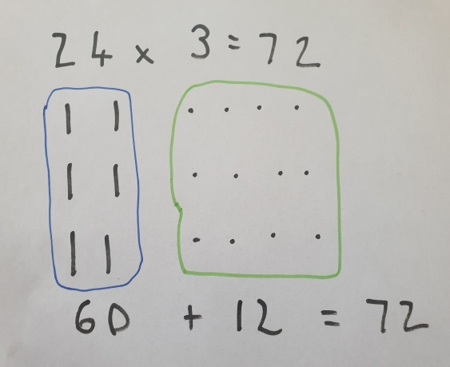
Multiplying a  2-digit number by a 1-digit number | Formal column method with place value counters.  3 × 23 | Children to represent the counters pictorially. | Children to record what it is they are doing to show understanding.  3 × 23  3 × 20 = 60  3 × 3 = 9  60 + 9 = 69
Multiplying a  2-digit number by a 1-digit number, expanded column method | Use place value equipment to model how 10 ones are exchanged for a 10 in some multiplications.  3 × 24 = ?  3 × 20 = 60  3 × 4 = 12  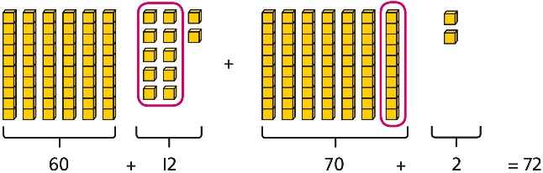  3 × 24 = 60 + 12  3 × 24 = 70 + 2  3 × 24 = 72 | Understand that multiplications may require an exchange of 1s for 10s, and also 10s for 100s.  4 × 23 = ?  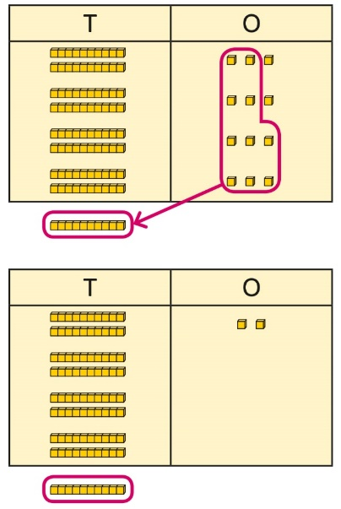  4 × 23 = 92  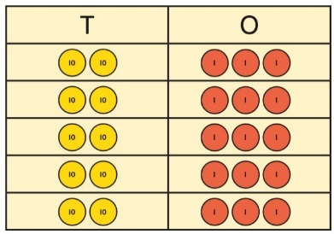  5 × 23 = ?  5 × 3 = 15  5 × 20 = 100  5 × 23 = 115 | Children may write calculations in expanded column form, but must understand the link with place value and exchange.  Children are encouraged to write the expanded parts of the calculation separately.  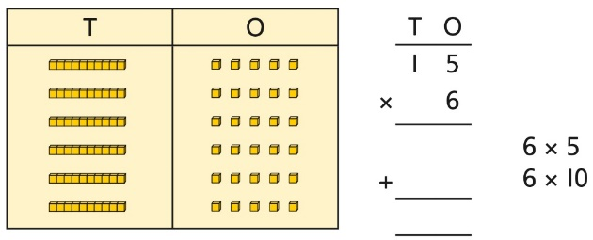  5 × 28 = ?  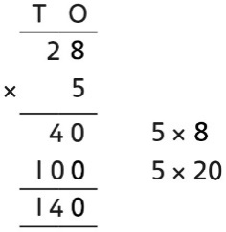
Year 3
Division
Using times-tables knowledge to divide | Use knowledge of known times-tables to calculate divisions.  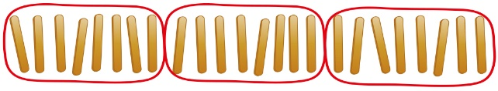  24 divided into groups of 8.  There are 3 groups of 8. | Use knowledge of known times-tables to calculate divisions.  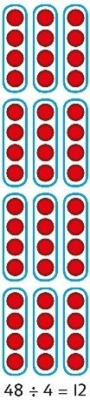  48 divided into groups of 4.  There are 12 groups.  4 × 12 = 48  48 ÷ 4 = 12 | Use knowledge of known times-tables to calculate divisions.  I need to work out 30 shared between 5.  I know that 6 × 5 = 30  so I know that 30 ÷ 5 = 6.  A bar model may represent the relationship between sharing and grouping.  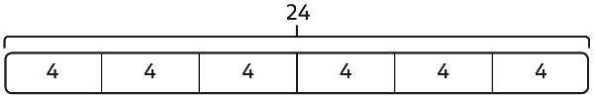  24 ÷ 4 = 6  24 ÷ 6 = 4  Children understand how division is related to both repeated subtraction and repeated addition.  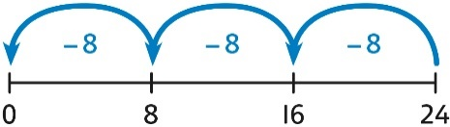  24 ÷ 8 = 3  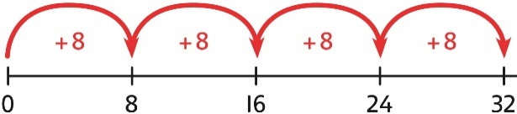  32 ÷ 8 = 4
Understanding remainders | Use equipment to understand that a remainder occurs when a set of objects cannot be divided equally any further.  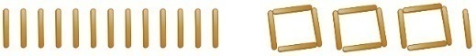  There are 13 sticks in total.  There are 3 groups of 4, with 1 remainder. | Use images to explain remainders.  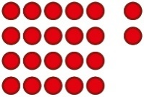  22 ÷ 5 = 4 remainder 2 | Understand that the remainder is what cannot be shared equally from a set.  22 ÷ 5 = ?  3 × 5 = 15  4 × 5 = 20  5 × 5 = 25 … this is larger than 22  So, 22 ÷ 5 = 4 remainder 2
Understanding remainders | 2d ÷ 1d with remainders using lollipop sticks. Cuisenaire rods, above a ruler can also be used.  13 ÷ 4  Use of lollipop sticks to form wholes- squares are made because we are dividing by 4.  There are 3 whole squares, with 1 left over. | Children to represent the lollipop sticks pictorially.  There are 3 whole squares, with 1 left over. | Children to be able to make sense of the place value counters and write calculations to show the process.  42 ÷ 3  42 = 30 + 12  30 ÷ 3 = 10  12 ÷ 3 = 4  10 + 4 = 14
Using known facts to divide multiples of 10 | Use place value equipment to understand how to divide by unitising.  Make 6 ones divided by 3.  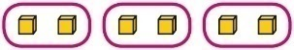  Now make 6 tens divided by 3.  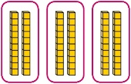  What is the same? What is different? | Divide multiples of 10 by unitising.  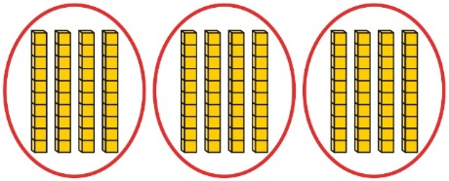  12 tens shared into 3 equal groups.  4 tens in each group. | Divide multiples of 10 by a single digit using known times-tables.  180 ÷ 3 = ?  180 is 18 tens.  18 divided by 3 is 6.  18 tens divided by 3 is 6 tens.  18 ÷ 3 = 6  180 ÷ 3 = 60
2-digit number divided by  1-digit number, no remainders | Children explore dividing 2-digit numbers by using place value equipment.  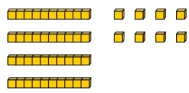  48 ÷ 2 = ?  First divide the 10s.  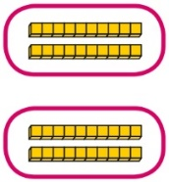  Then divide the 1s.  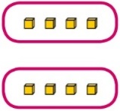 | Pictorial by sharing:  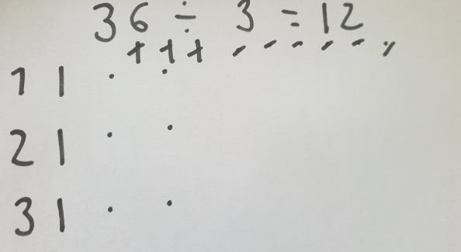  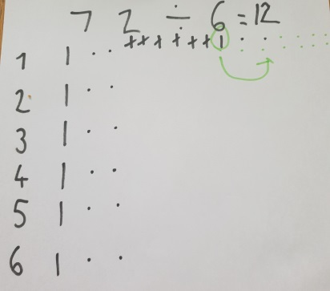  Pictorially by grouping:  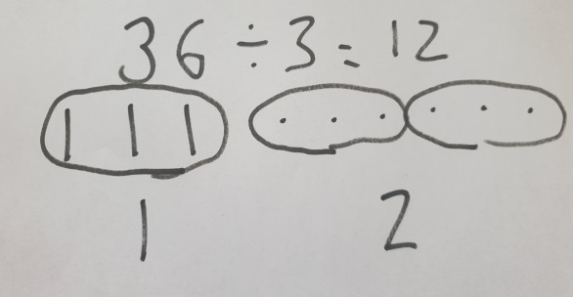  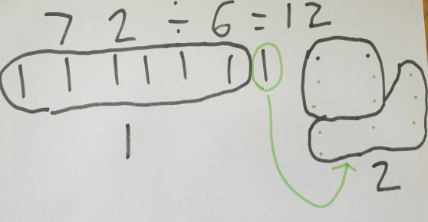 | Method one – partitioning  Children partition a number into 10s and 1s to divide where appropriate.  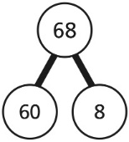  60 ÷ 2 = 30  8 ÷ 2 = 4  30 + 4 = 34  68 ÷ 2 = 34  Children partition flexibly to divide where appropriate.  42 ÷ 3 = ?  42 = 40 + 2  I need to partition 42 differently to divide by 3.  42 = 30 + 12  30 ÷ 3 = 10  12 ÷ 3 = 4  10 + 4 = 14  42 ÷ 3 = 14  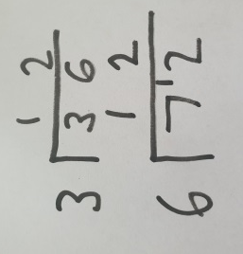  Method two – bus stop (short division)
2-digit number divided by  1-digit number, with remainders | Use place value equipment to understand the concept of remainder.  Make 29 from place value equipment.  Share it into 2 equal groups.  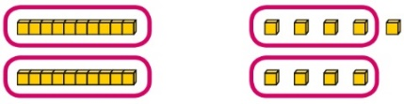  There are two groups of 14 and  1 remainder.  Use place value equipment to understand the concept of remainder in division.  29 ÷ 2 = ?  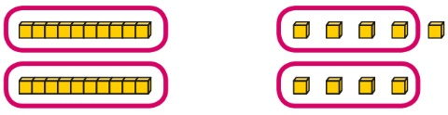  29 ÷ 2 = 14 remainder 1 | Pictorially by sharing:  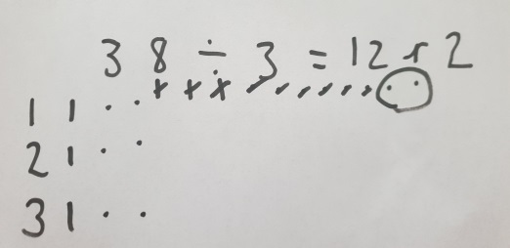  Pictorially by grouping:  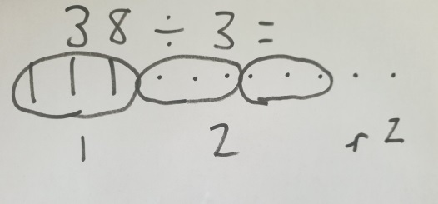 | Method one – partitioning  Partition to divide, understanding the remainder in context.  67 children try to make 5 equal lines.  67 = 50 + 17  50 ÷ 5 = 10  17 ÷ 5 = 3 remainder 2  67 ÷ 5 = 13 remainder 2  There are 13 children in each line and  2 children left out.  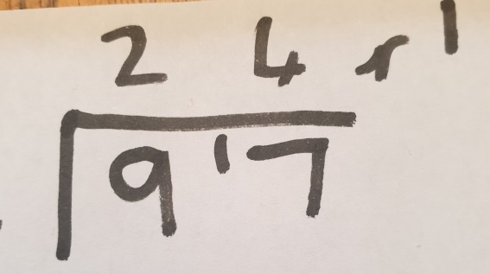  Method two – bus stop (short division)
Year 4
 | Concrete | Pictorial | Abstract
Year 4
Addition
Understanding numbers to 10,000 | Use place value equipment to understand the place value of 4-digit numbers.  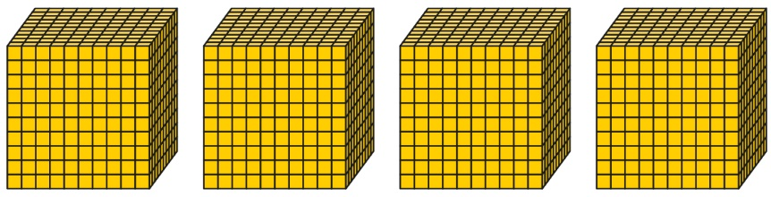  4 thousands equal 4,000.  1 thousand is 10 hundreds.  Represent numbers using place value counters once children understand the relationship between 1,000s and 100s.  2,000 + 500 + 40 + 2 = 2,542 | 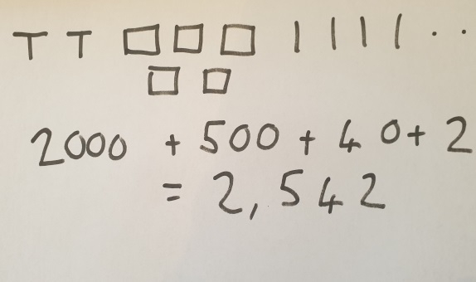  Drawing numbers to represent the value of each digit and subsequently adding the values together. | Understand partitioning of 4-digit numbers, including numbers with digits of 0.  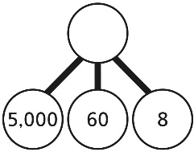  5,000 + 60 + 8 = 5,068  Understand and read 4-digit numbers on a number line.  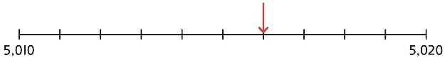
Choosing mental methods where appropriate | Use unitising and known facts to support mental calculations.  Make 1,405 from place value equipment.  Add 2,000.  Now add the 1,000s.  1 thousand + 2 thousands = 3 thousands  1,405 + 2,000 = 3,405 | Use unitising and known facts to support mental calculations.  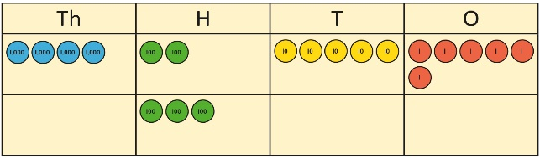  I can add the 100s mentally.  200 + 300 = 500  So, 4,256 + 300 = 4,556 | Use unitising and known facts to support mental calculations.  4,256 + 300 = ?  2 + 3 = 5 200 + 300 = 500  4,256 + 300 = 4,556
Column addition with exchange | Use place value equipment on a place value grid to organise thinking.  Ensure that children understand how the columns relate to place value and what to do if the numbers are not all 4-digit numbers.  Use equipment.to show 1,905 + 775.  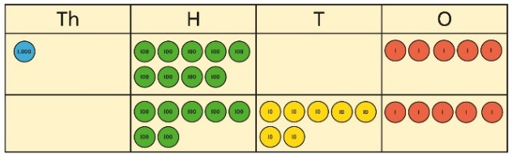  Why have only three columns been used for the second row? Why is the Thousands box empty?  Which columns will total 10 or more?  Use place value equipment to model required exchanges.  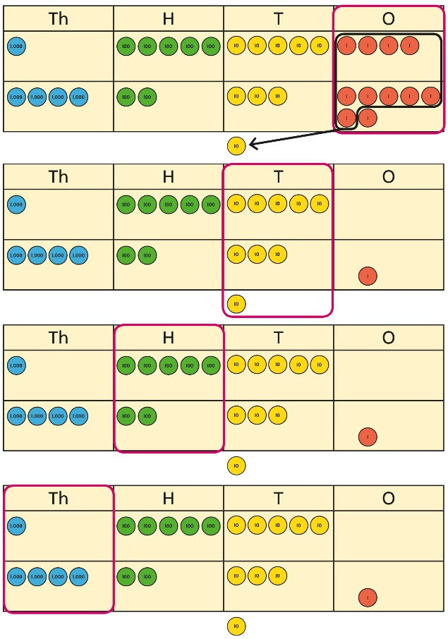  Include examples that exchange in more than one column. | Using pictorial representations to show what happens when we exchange.  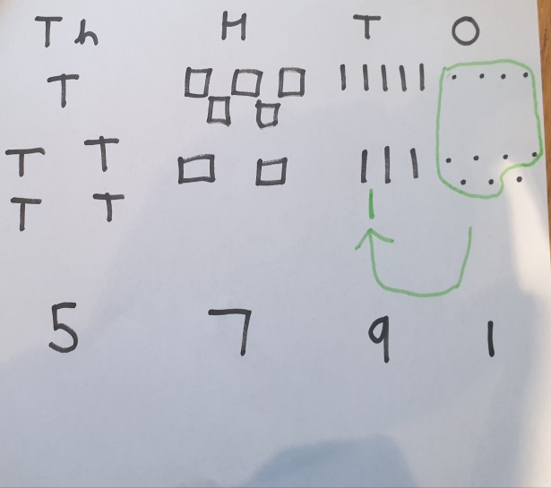 | Use a column method to add, including exchanges.  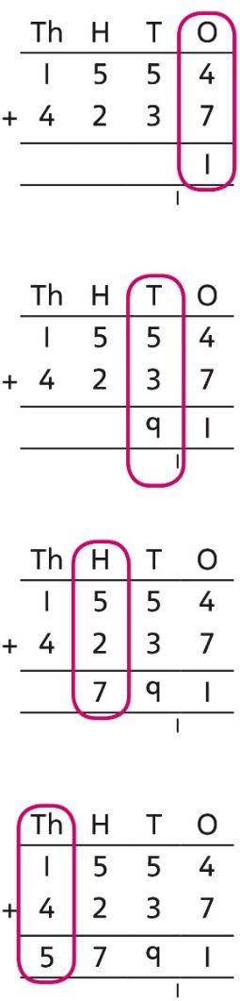  Include examples that exchange in more than one column.
Representing additions and checking strategies |  | Bar models may be used to represent additions in problem contexts, and to justify mental methods where appropriate.  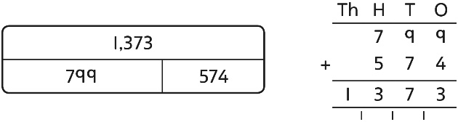  I chose to work out 574 + 800,  then subtract 1.  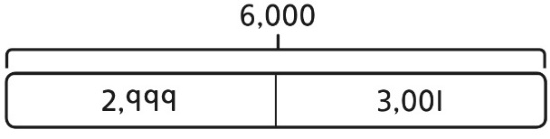  This is equivalent to 3,000 + 3,000. | Use rounding and estimating on a number line to check the reasonableness of an addition.  912 + 6,149 = ?  I used rounding to work out that the  answer should be approximately  1,000 + 6,000 = 7,000.
Year 4
Subtraction
Choosing mental methods where appropriate | Use place value equipment to justify mental methods.  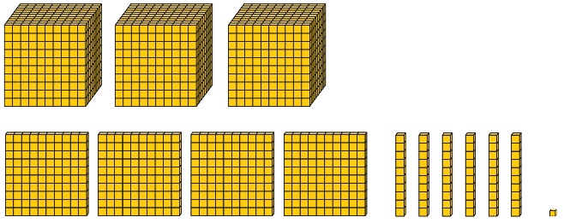  What number will be left if we take away 300? | Use place value grids to support mental methods where appropriate.  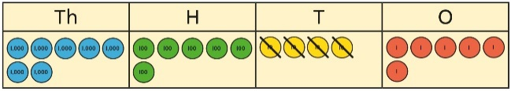  7,646 − 40 = 7,606 | Use knowledge of place value and unitising to subtract mentally where appropriate.  3,501 − 2,000  3 thousands − 2 thousands = 1 thousand  3,501 − 2,000 = 1,501
Column subtraction with exchange | Understand why exchange of a 1,000 for 100s, a 100 for 10s, or a 10 for 1s may be necessary.  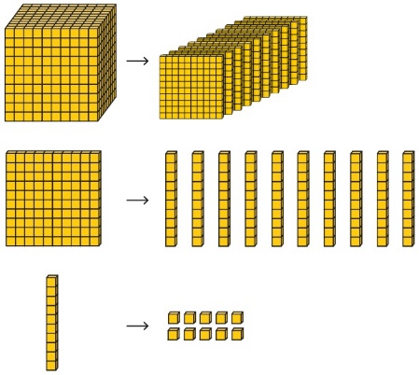  Represent place value equipment on a place value grid to subtract, including exchanges where needed.  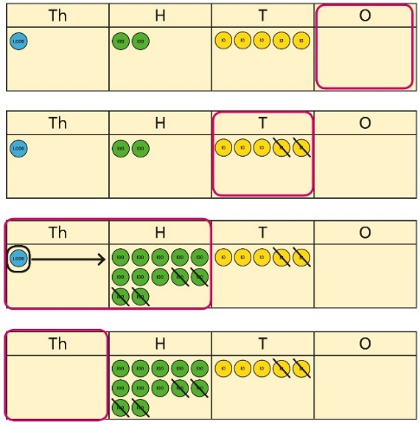 | Representing the exchange pictorially through drawing dienes.  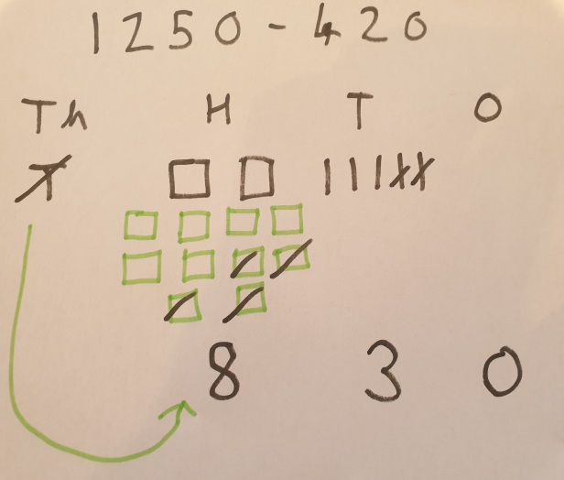 | Use column subtraction, with understanding of the place value of any exchange required.  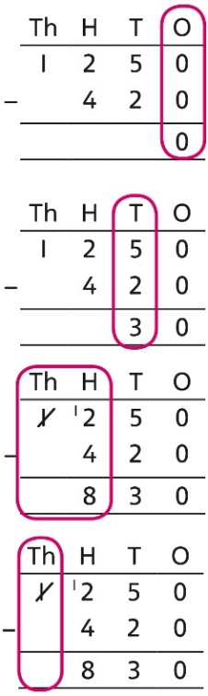
Column subtraction with exchange across more than one column | Understand why two exchanges may be necessary.  2,502 − 243 = ?  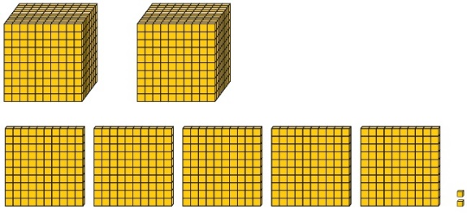  I need to exchange a 10 for some 1s, but there are not any 10s here.  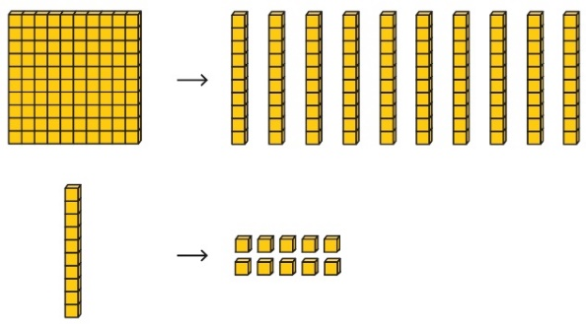  Make exchanges across more than one column where there is a zero as a place holder.  2,502 − 243 = ?  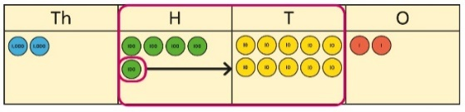  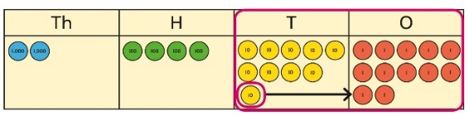 | Model exchanges using pictorial representations of dienes.  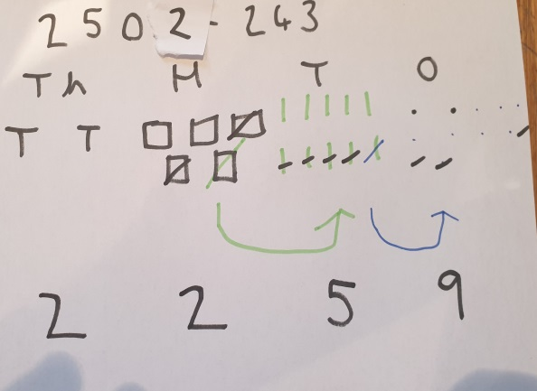 | Make exchanges across more than one column where there is a zero as a place holder.  2,502 − 243 = ?  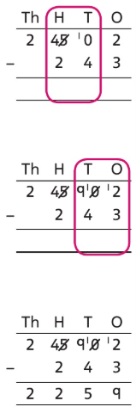
Representing subtractions and checking strategies |  | Use bar models to represent subtractions where a part needs to be calculated.  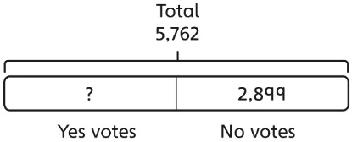  I can work out the total number of Yes votes using 5,762 − 2,899.  Bar models can also represent ‘find the difference’ as a subtraction problem.  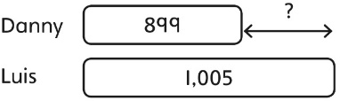 | Use inverse operations to check subtractions.  I calculated 1,225 − 799 = 574.  I will check by adding the parts.  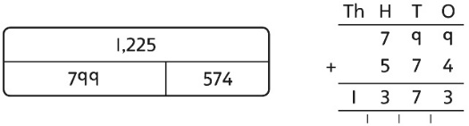  The parts do not add to make 1,225.  I must have made a mistake.
Year 4
Multiplication
Multiplying by multiples of 10 and 100 | Use unitising and place value equipment to understand how to multiply by multiples of 1, 10 and 100.  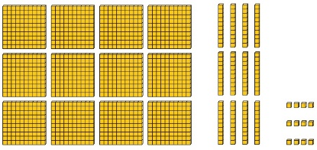  3 groups of 4 ones is 12 ones.  3 groups of 4 tens is 12 tens.  3 groups of 4 hundreds is 12 hundreds. | Use unitising and place value equipment to understand how to multiply by multiples of 1, 10 and 100.  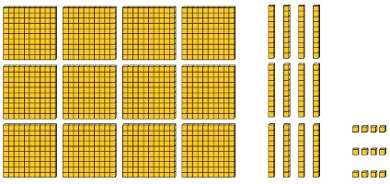  3 × 4 = 12  3 × 40 = 120  3 × 400 = 1,200 | Use known facts and understanding of place value and commutativity to multiply mentally.  4 × 7 = 28  4 × 70 = 280  40 × 7 = 280  4 × 700 = 2,800  400 × 7 = 2,800
Understanding times-tables up to 12 × 12 | Understand the special cases of multiplying by 1 and 0.  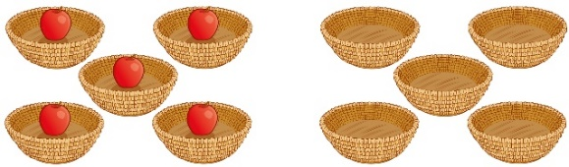  5 × 1 = 5 5 × 0 = 0 | Represent the relationship between the ×9 table and the ×10 table.  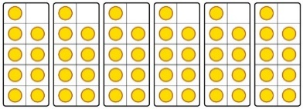  Represent the ×11 table and ×12 tables in relation to the ×10 table.  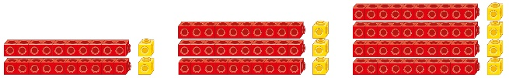  2 × 11 = 20 + 2  3 × 11 = 30 + 3  4 × 11 = 40 + 4  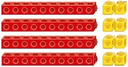  4 × 12 = 40 + 8 | Understand how times-tables relate to counting patterns.  Understand links between the  ×3 table, ×6 table and ×9 table  5 × 6 is double 5 × 3  ×5 table and ×6 table  I know that 7 × 5 = 35  so I know that 7 × 6 = 35 + 7.  ×5 table and ×7 table  3 × 7 = 3 × 5 + 3 × 2  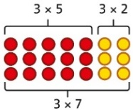  ×9 table and ×10 table  6 × 10 = 60  6 × 9 = 60 − 6
Understanding and using partitioning in multiplication | Make multiplications by partitioning.  4 × 12 is 4 groups of 10 and 4 groups of 2.  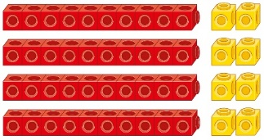  4 × 12 = 40 + 8 | Understand how multiplication and partitioning are related through addition.  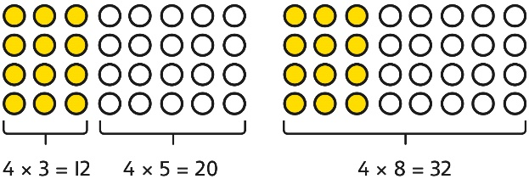  4 × 3 = 12  4 × 5 = 20  12 + 20 = 32  4 × 8 = 32 | Use partitioning to multiply 2-digit numbers by a single digit.  18 × 6 = ?  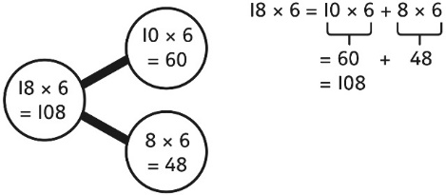  18 × 6 = 10 × 6 + 8 × 6  = 60 + 48  = 108
Understanding and using partitioning in multiplication | Partition to multiply using numicon, dienes or Cuisenaire rods.  4 × 15 | Children to represent the concrete manipulatives pictorially. | Children to be encouraged to show the steps they have taken.  A number line can also be used
Column multiplication for 2- and  3-digit numbers multiplied by a single digit | Use place value equipment to make multiplications.  Make 4 × 136 using equipment.  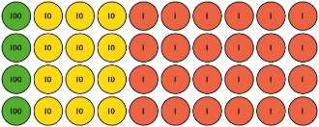  I can work out how many 1s, 10s and 100s.  There are 4 × 6 ones… 24 ones  There are 4 × 3 tens … 12 tens  There are 4 × 1 hundreds … 4 hundreds  24 + 120 + 400 = 544 | Use place value equipment alongside a column method for multiplication of up to  3-digit numbers by a single digit.  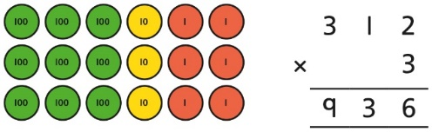  Use pictorial representations of dienes to multiply.  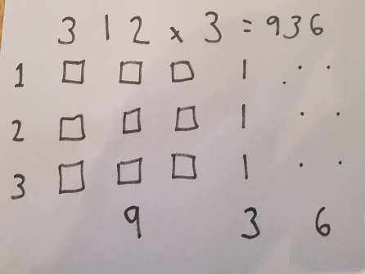 | Use the formal column method for up to  3-digit numbers multiplied by a single digit.  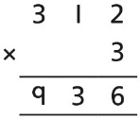  Understand how the expanded column method is related to the formal column method and understand how any exchanges are related to place value at each stage of the calculation.  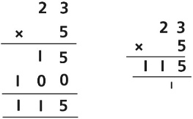
Multiplying more than two numbers | Represent situations by multiplying three numbers together.    Each sheet has 2 × 5 stickers.  There are 3 sheets.  There are 5 × 2 × 3 stickers in total.  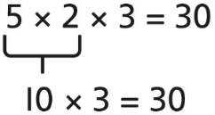 | Understand that commutativity can be used to multiply in different orders.  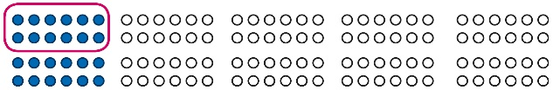  2 × 6 × 10 = 120  12 × 10 = 120  10 × 6 × 2 = 120  60 × 2 = 120 | Use knowledge of factors to simplify some multiplications.  24 × 5 = 12 × 2 × 5  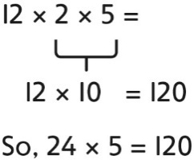
Year 4
Division
Understanding the relationship between multiplication and division, including times-tables | Use objects to explore families of multiplication and division facts.  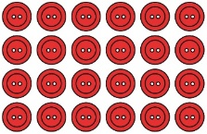  4 × 6 = 24  24 is 6 groups of 4.  24 is 4 groups of 6.  24 divided by 6 is 4.  24 divided by 4 is 6. | Represent divisions using an array.  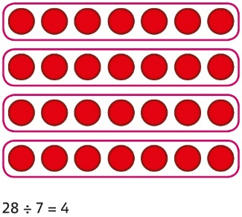 | Understand families of related multiplication and division facts.  I know that 5 × 7 = 35  so I know all these facts:  5 × 7 = 35  7 × 5 = 35  35 = 5 × 7  35 = 7 × 5  35 ÷ 5 = 7  35 ÷ 7 = 5  7 = 35 ÷ 5  5 = 35 ÷ 7
Dividing multiples of 10 and 100 by a single digit | Use place value equipment to understand how to use unitising to divide.  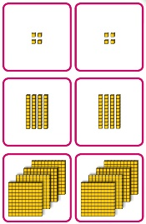  8 ones divided into 2 equal groups  4 ones in each group  8 tens divided into 2 equal groups  4 tens in each group  8 hundreds divided into 2 equal groups  4 hundreds in each group | Represent divisions using place value equipment.  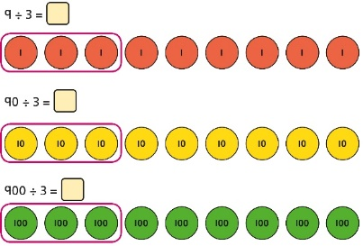  9 ÷ 3 = 3  9 tens divided by 3 is 3 tens.  9 hundreds divided by 3 is 3 hundreds. | Use known facts to divide 10s and 100s by a single digit.  15 ÷ 3 = 5  150 ÷ 3 = 50  1500 ÷ 3 = 500
Dividing 2-digit and 3-digit numbers by a single digit by partitioning into 100s, 10s and 1s | Partition into 10s and 1s to divide where appropriate.  39 ÷ 3 = ?  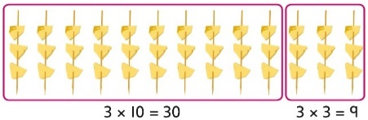  39 = 30 + 9  30 ÷ 3 = 10  9 ÷ 3 = 3  39 ÷ 3 = 13 | Partition into 100s, 10s and 1s using Base 10 equipment to divide where appropriate.  39 ÷ 3 = ?  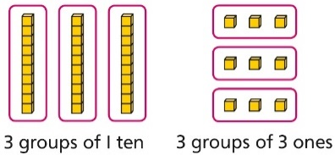  39 = 30 + 9  30 ÷ 3 = 10  9 ÷ 3 = 3  39 ÷ 3 = 13 | Partition into 100s, 10s and 1s using a part-whole model to divide where appropriate.  142 ÷ 2 = ?  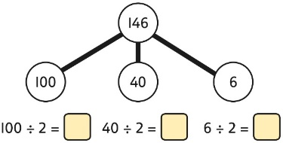  100 ÷ 2 = 50  40 ÷ 2 = 20  6 ÷ 2 = 3  50 + 20 + 3 = 73  142 ÷ 2 = 73
Dividing 2-digit and 3-digit numbers by a single digit, using flexible partitioning | Use place value equipment to explore why different partitions are needed.  42 ÷ 3 = ?  I will split it into 30 and 12, so that I can divide by 3 more easily.  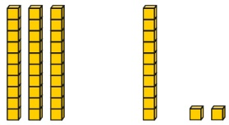 | Represent how to partition flexibly where needed.  84 ÷ 7 = ?  I will partition into 70 and 14 because I am dividing by 7.  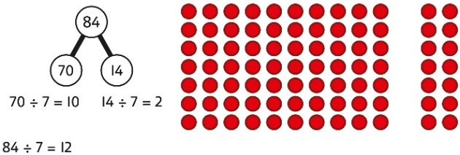 | Make decisions about appropriate partitioning based on the division required.  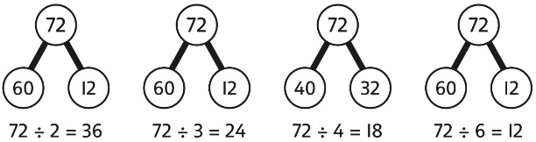  Understand that different partitions can be used to complete the same division.  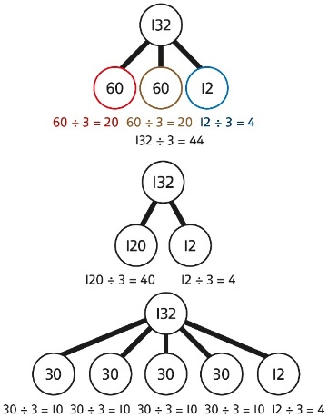
Divide 2 and 3 digit numbers by a single digit | Can be done practically with dienes or through pictorial representations (as below)  Sharing  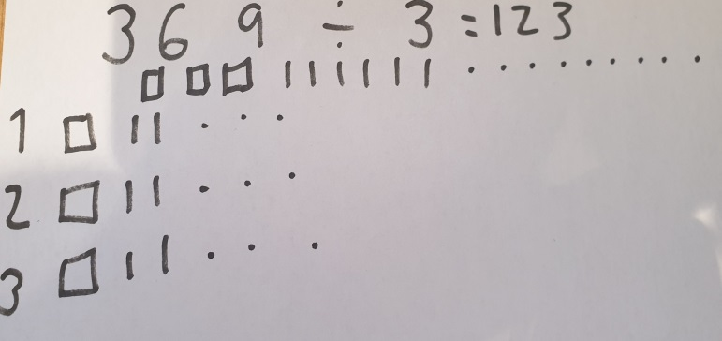  Grouping  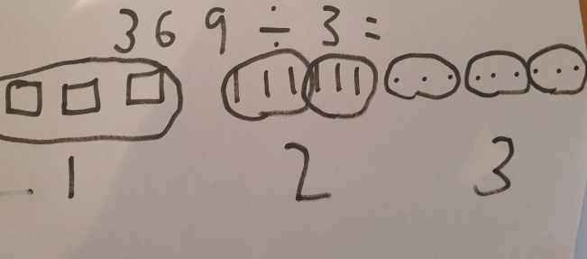 |  | Bus stop (short division)  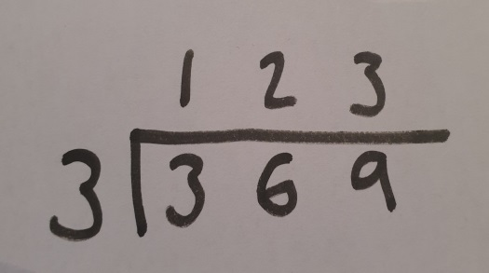
Short division using place value counters to group | 1. Make 615 with place value counters.  2. How many groups of 5 hundreds can you make with 6 hundred counters?  3. Exchange 1 hundred for 10 tens.  4. How many groups of 5 tens can you make with 11 ten counters?  5. Exchange 1 ten for 10 ones.  6. How many groups of 5 ones can you make with 15 ones? | Represent the counters pictorially. | Children to the calculation using the short division ‘bus stop’ scaffold
Understanding remainders | Use place value equipment to find remainders.  85 shared into 4 equal groups  There are 24, and 1 that cannot be shared.  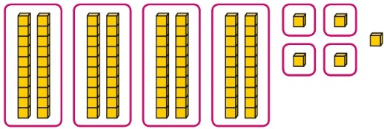 | Represent the remainder as the part that cannot be shared equally.  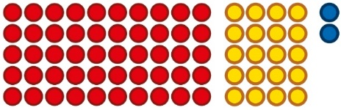  72 ÷ 5 = 14 remainder 2  Sharing  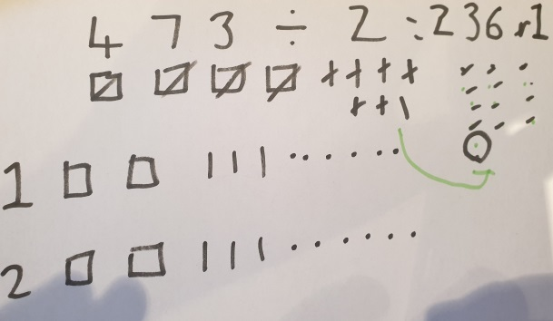  Grouping  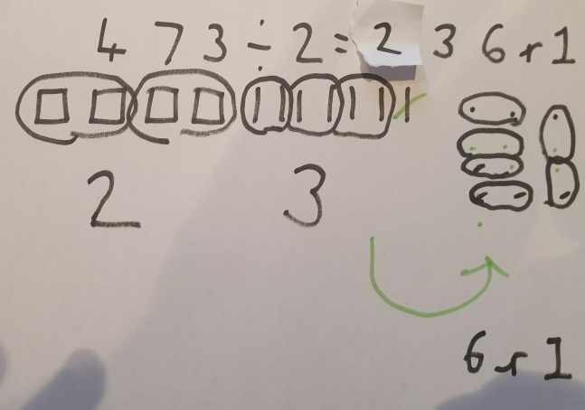 | Method one – partitioning  Understand how partitioning can reveal remainders of divisions.  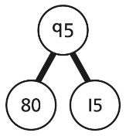  80 ÷ 4 = 20  12 ÷ 4 = 3  95 ÷ 4 = 23 remainder 3  Method two – bus stop (short division)  

