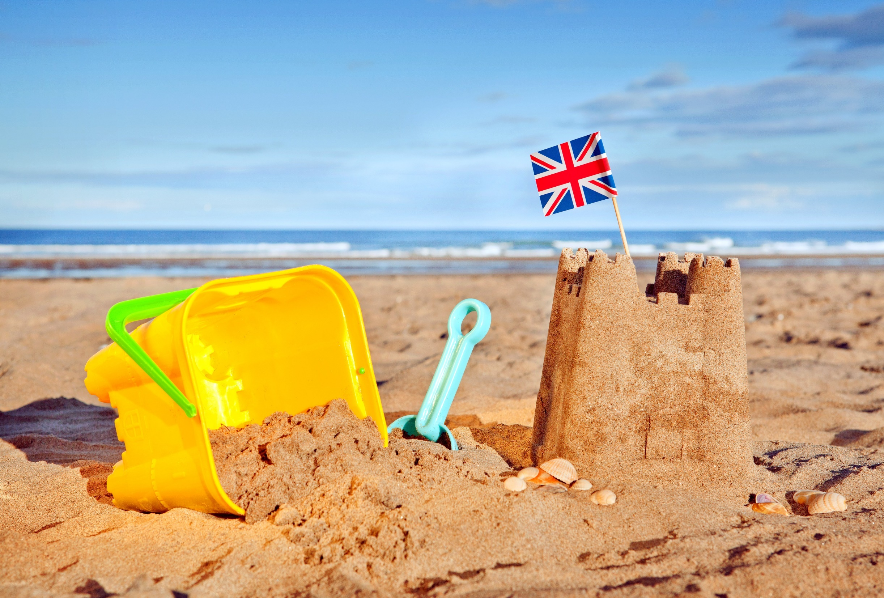
Thank you for your continued support.

Mr Parsons and Mrs Stoodley
In Geography, we will be answering the enquiry question, ‘Are all beaches the same?’ by looking at our local beaches and comparing them to Lulworth Cove. The children will also be working on their map skills by identifying landforms such as rivers, sea, woods, roads, mountains on a map.
In Art, we will be learning about the artist, Hokusai. We will be printing shapes to create a seaside picture.
In RE, we will be learning about the Creation story in Hinduism.
In Maths, the children will begin to look at basic multiplication using arrays before moving on to cover time, fractions (halves and quarters) and shape.
In PE, we will be using our fielding and striking skills, dance and fitness as well as getting ready for Sports Day!
In Science, we will be looking at plants and what they need to grow and survive. We have planted flowers and vegetables. We are going to be looking after them and recording what happens.
In English, we will be looking at the wordless story, The Wave, by Suzy Lee. The children will be creating their own versions of the story to match the beautiful pictures!
Oh, I Do Like to be Beside the Seaside!
Term 6
In History, we will be learning about the changes in the Bournemouth as a seaside town over time. We will also be focusing on Mary Anning, the famous fossil hunter, as a historical person of interest.
In Computing, we will be creating our own animated story books.

