Design  Design a treasure map, choose a starting point and write instructions to help someone find the treasure. Remember to put the compass points on your map.  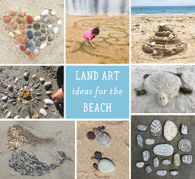  Design your own sand art if you visit the beach or take some ideas from the beach home with you and make a picture out of the shells, stones or object you have found. | Create  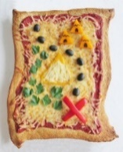  Cook a pirate map pizza – instructions are found here http://wonderlandrecipes.com/2015/04/09/neverland-pirate-map-pizza/  Make a seaside in a jar. You could use real things from the beach like sand, shells and seaweed.  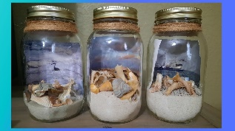 | Visit  Draw a map of your local area and design a treasure hunt for your family and friends.  Go for a walk along the beach. What features of the seaside can you see? Write a recount/diary about your day.  Create a postcard from a place you have visited.
Research  Find out more about fossil hunting on the Jurassic Coast by watching this video.  https://www.bbc.co.uk/teach/class-clips-video/articles/zbbrkmn  Find out information, write interesting facts about The Royal National Lifeboat Institution, also called the RNLI, and the work they do to keep us safe on our coasts. | Write  Write a seaside themed story or poem.  Write five special things you would put in a treasure chest to bury in the sand and why.  Create an A-Z of things to do whilst visiting the beach.  Learn some beach tongue twisters and riddles. Can you write some of your own?  eg Big, blue, beach balls bouncing on the beach!  You can then use it to challenge the rest of the class! | Books to read  The Odd Fish- Naomi Jones  Look what I found at the Beach- Moira Butterfield  The Lighthouse Keeper’s Lunch- Ronda Armitage  The See Saw- Tom Percival  Pirates Love Underpants – Claire Freedman  Atlases and Google Maps – look at countries and places you have visited. Look at the area where you live.
Please choose a task to complete over the course of the project, you are welcome to do more than one.
We would love to receive as many pieces of home learning as possible to display on our Wow Walls! Please bring your work into school to share with us, you can also email photos to the school office who will forward them on for us to share. Have fun home learning!

